

Powder Puzzles

Kit #12
Black Line Masters

Revised June 2008 OCM BOCES Science Center

Logo and footers-revision June 2008

Aluminum | Iron
Copper | Zinc
Plaster of Paris | Citric acid

Salt | Sugar
Water | Epsom Salt

Sand | Baking Soda
Vinegar | BTB
Corn Starch

Session 2: Reference List for Sample Materials

List 1: Chemical Names
Common Name | “Chemical Name” | Chemical Formula
aluminum | Aluminum
baking soda | Sodium bicarbonate
BTB | Bromothymol blue
citric acid | Citric acid
copper | Copper
corn starch | Corn starch
epsom salt | Magnesium sulfate
iron | Iron
plaster of paris | Calcium sulfate
salt | Sodium chloride
sand | Silicon dioxide
sugar | Sucrose
vinegar | Acetic acid
water | Water
zinc | zinc

List 2: Chemical Names and Chemical Formulas
Common Name | “Chemical Name” | Chemical Formula
aluminum | Aluminum | Al
baking soda | Sodium bicarbonate | NaHCO₃
BTB | Bromothymol blue | C₂₇H₂₈Br₂O₅S
citric acid | Citric acid | C₆H₈O₇
copper | Copper | Cu
corn starch | Corn starch | (C₆H₁₂O₅)_{n}
epsom salt | Magnesium sulfate | MgSO₄
iron | Iron | Fe
plaster of paris | Calcium sulfate | Ca₂H₂O₉S₂
salt | Sodium chloride | NaCl
sand | Silicon dioxide | SiO₂
sugar | Sucrose | C₆H₁₂O₆
vinegar | Acetic acid | C₂H₄O₂
water | Water | H₂O
zinc | zinc | Zn

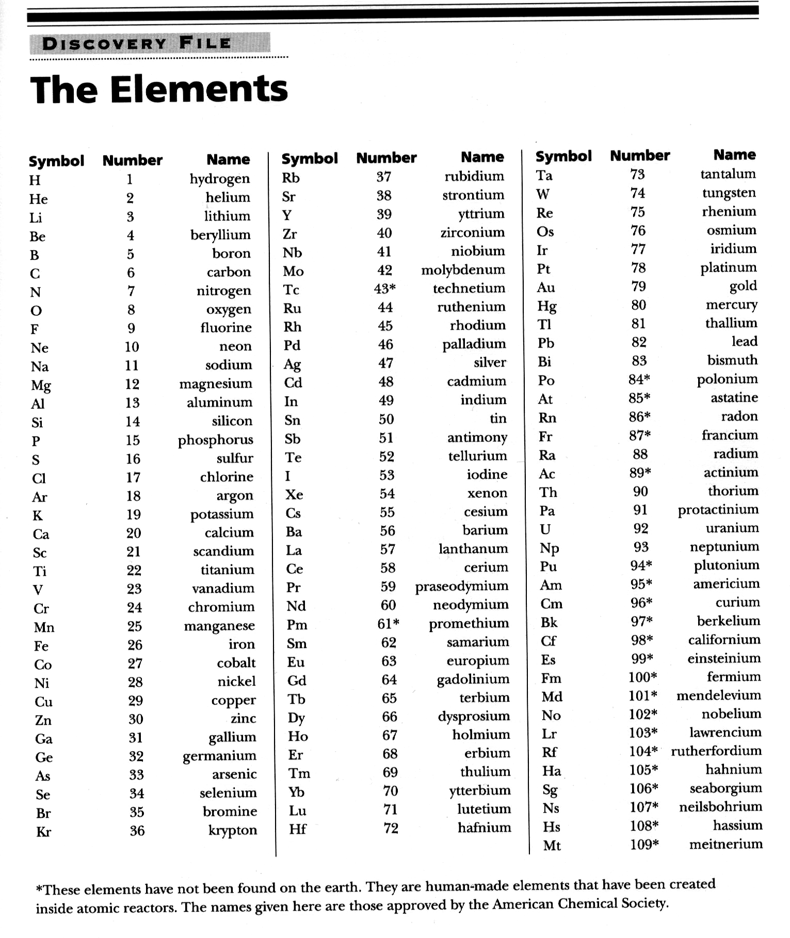

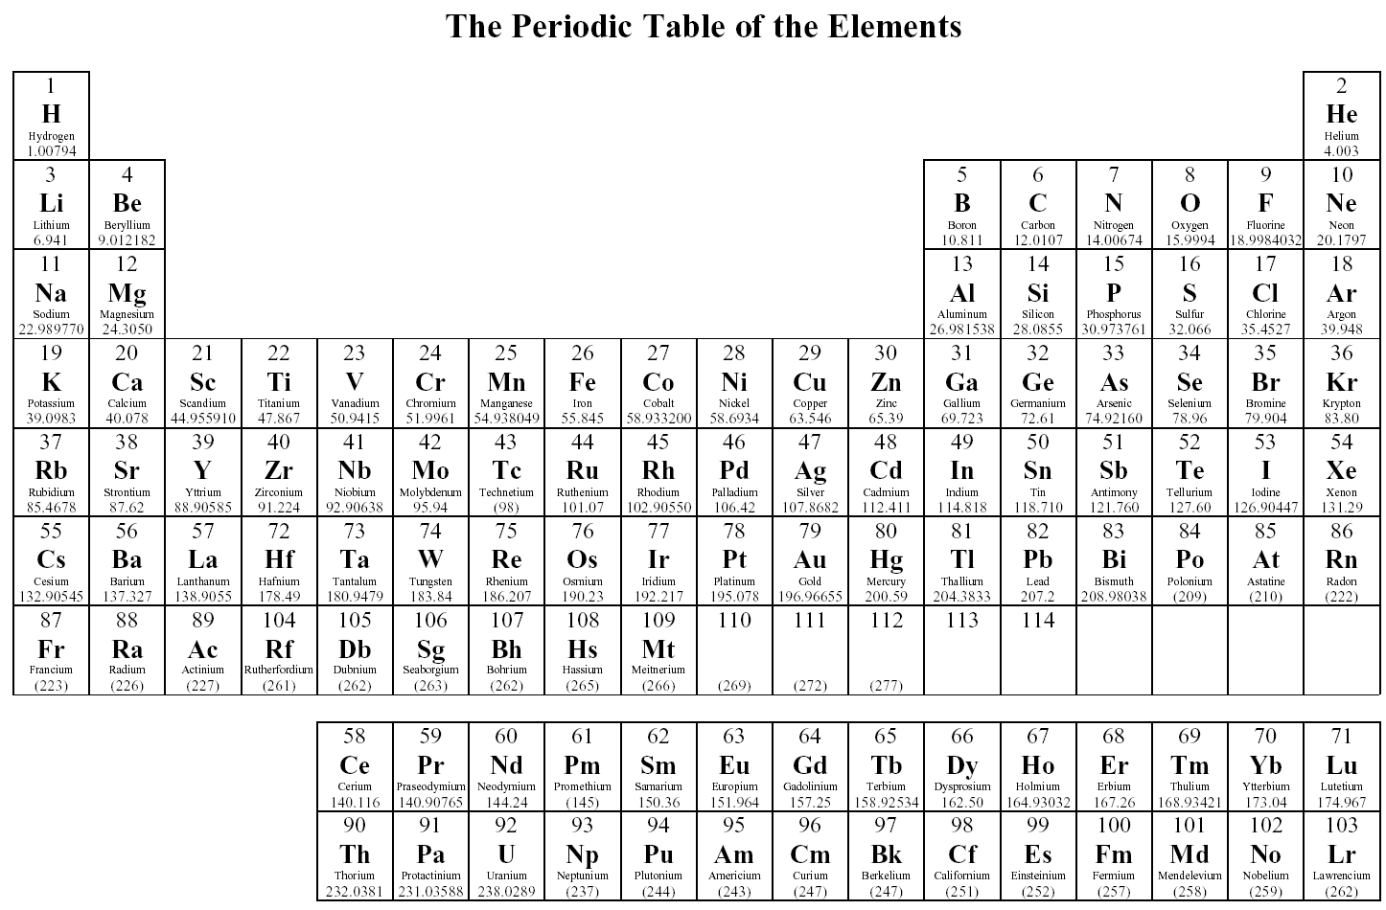
1.
Match a substance from List A with a property from List B by writing the letter of the property on the blank line front of the substance.

List A: Substance | List B: Property.
______ water | A. red color
______ paper | B. cold
______ iron metal | C. conducts electricity
______ copper wire | D. very hard
______ diamond | E. burns
______ ruby | F. freezes at 0˚C
 | G. beautiful
 | H. rusts

2. Using the Periodic Table as a reference, place an E in front of the substances in the list that are Elements, a C in front of those that are Compounds and a N for those that are Neither.

Calcium chloride (CaCl)
Water (H₂0)
Silicon (Si)
Gold (Au)
Sand (SiO₂ )
Hydrogen (H)

- True or False, write true or false in front of each statement.
If the statement is False, rewrite it the right way.

A. _____ Elements are made up of atoms.

B. _____ All atoms are exactly alike.

C. _____ All atoms of an element are exactly alike.

D. _____ Since water is a compound made up of Hydrogen and Oxygen, it is made up of 2 different types of atoms.

E. _____ Molecules make up elements.

F. _____ All molecules of water are exactly alike.

Challenge Question:

7. The air around us is made up of 21% O₂ (oxygen molecules) and 78% N₂ (nitrogen molecules).
If you add 21% and 78% you get a total of 99%. For percentages 100% is the whole thing. Therefore, most of all the air is made up of oxygen and nitrogen.

Using your Periodic Table as a resource, try to give a reason why a balloon filled with Helium (He₂) rises or floats in the “sea” of air that surrounds us.

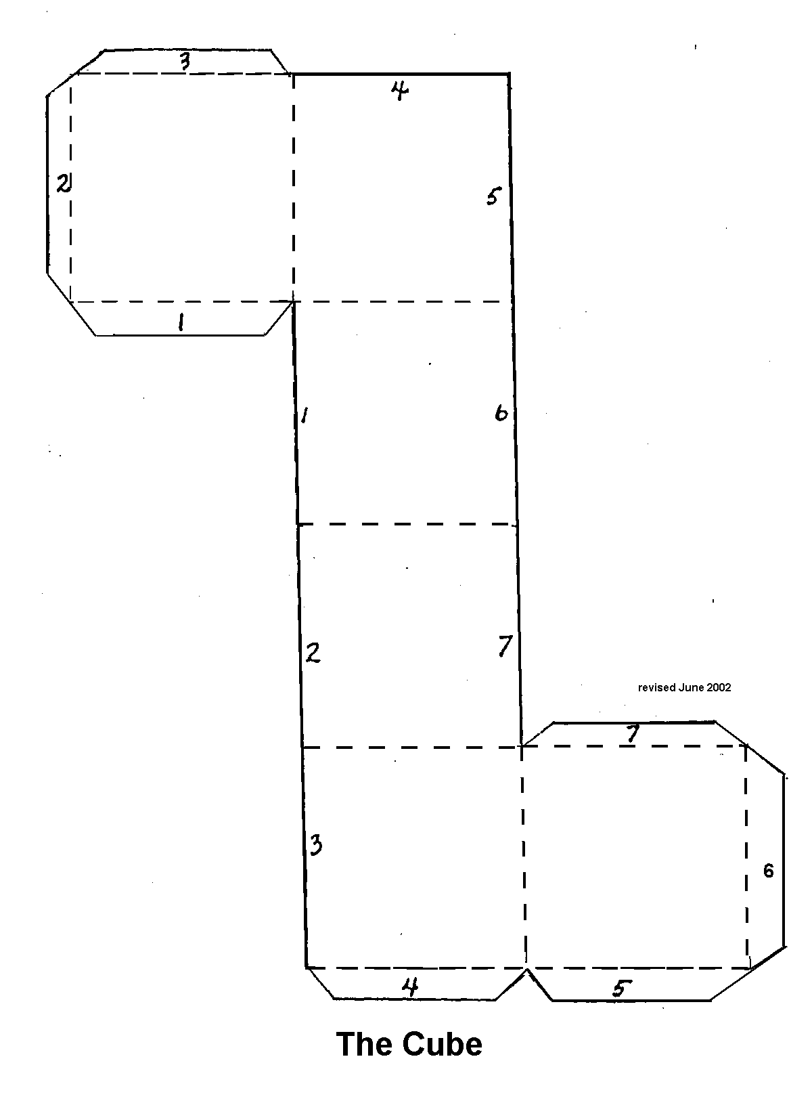

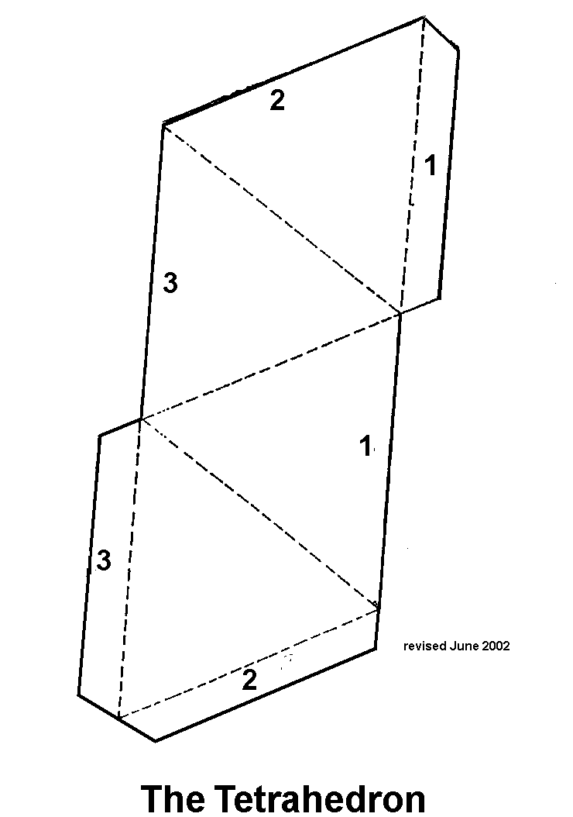

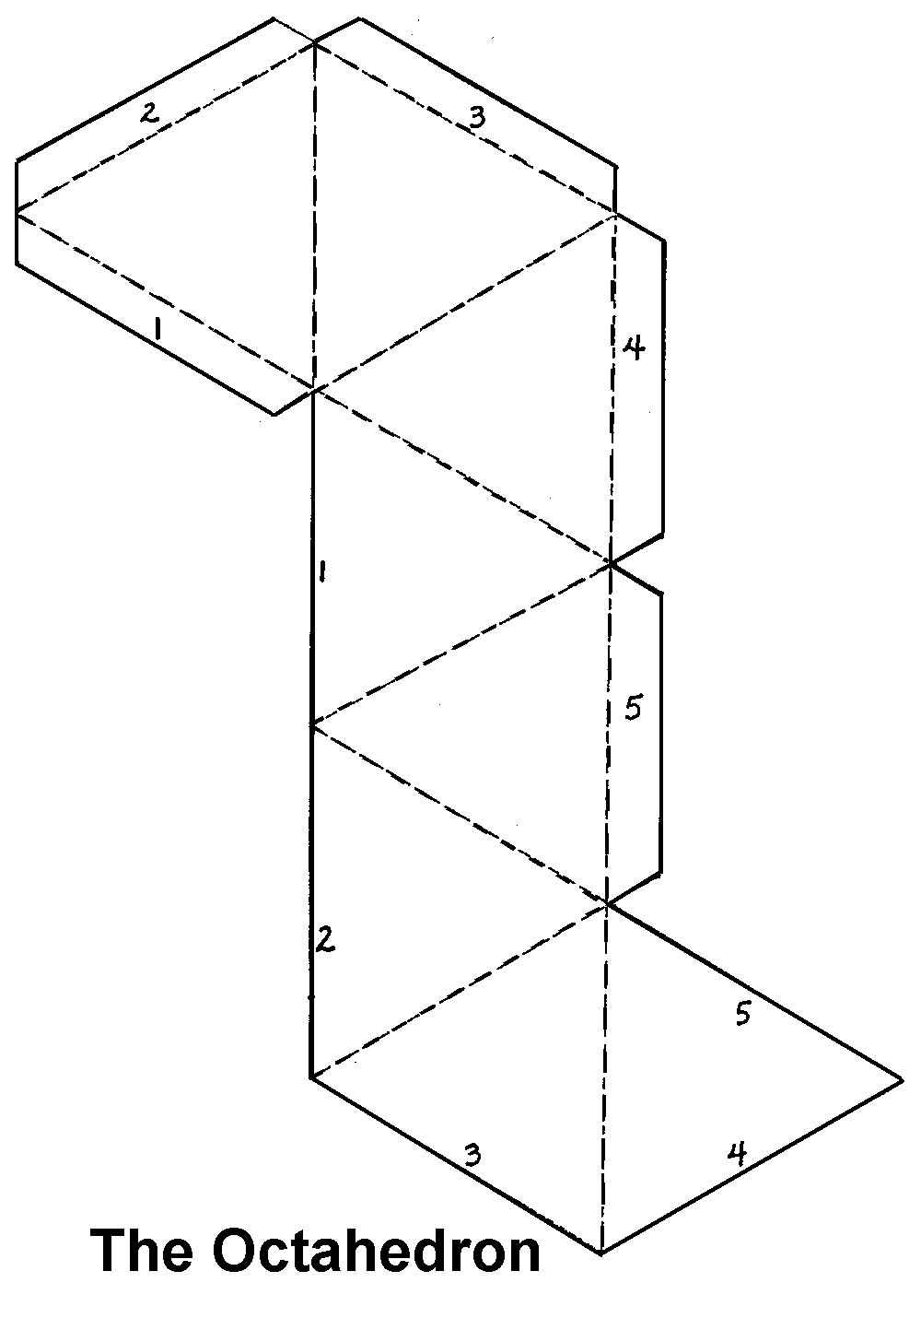

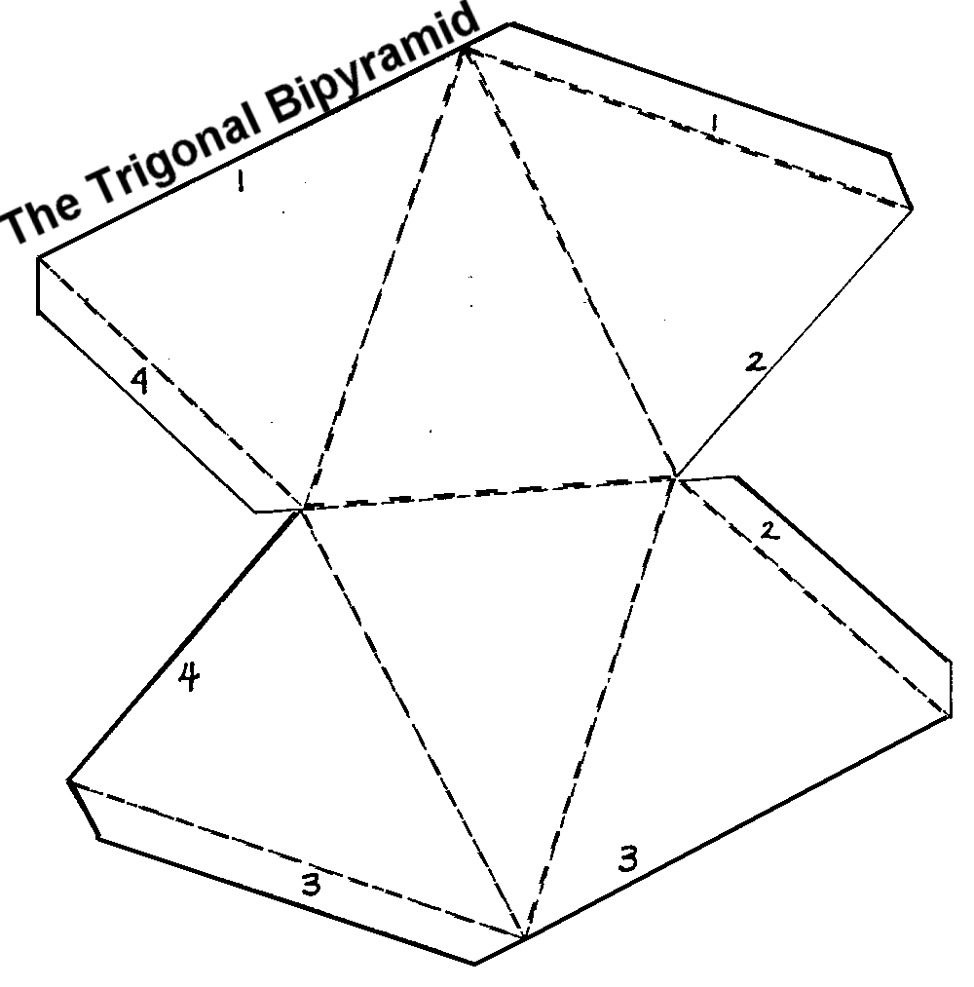

Powder Puzzles Evaluation 2; This worksheet reviews many of the concepts you explored in the “WHO DID IT Lab “ experience. Some questions are direct answer, some are thought provoking, You may use your Lab Journal as a resource. You do not have to do the questions in order.

- In “Session 2: It’s Elemental My Dear Newbie” you explored elements and compounds. After observing each of the samples the question was asked “Which are elements and which are compounds?” You went through a process of gathering information about each of the samples (such as, the common name, chemical name, chemical formula, if found on Periodic Table). From this information you made a conclusion about each of the samples. The conclusion was whether it was an element or compound.

At this point answer one of the following:
- Someone asks you “How can you tell if a substance is an element or compound?”, give them an answer.

- Develop a way of finding out whether a substance is an element or a compound. Tell what information you would need about the substance. Tell how you would use the information.

2. You will be drawing circles in the containers below. Draw small circles to show the spacing between molecules of a solid, liquid or a gas. (The liquid is done for you.)

State: SOLID LIQUID GAS

- In which container (state) do the molecules have more energy of motion? __________

- In which container (state) are the molecules bound together most strongly?_________

3. Which tend to be larger, atoms or molecules? ________________ Why?

4. Define the term “crystal”.

5. Give at least one reason for chemists to study crystal shapes of substances.

6. Draw a common crystal shape.

7. Give 3 substances commonly found in a crystal form.

8. In the USA the chemical formula for water is H₂O, what is the chemical formula for water in France?

9. What does the chemical formula for water, H₂O, tell you about this compound?

10. How does the term “mixture” describe a rainbow?

11. Tell what “Chromatography” is used for.

12. Give two examples of a compound.

13. Matching: Draw a line from the substance to it’s properties.

Solid
 | Property
• | A. Has a Volume (takes up a measurable amount of space)
• | C. Has a Shape (able to grab onto, able to hold in your hand)
• | D. Has no definite shape (shape is easily changed)
• | E. Strong Bonds or Weak Bonds ( hard to pull apart)
• | F. Weak Bonds (easy to pull apart)

Liquid

Gas

14. If you had a newspaper, what could you do to it that would be a physical change? (see Session 7)

- What could you do to the newspaper to have it undergo a chemical change?

- What is the difference between a physical change and a chemical change? (think in terms of: chemical make up and chemical properties).

- In Sessions 8 - 13, list 5 characteristic properties used to compare the samples.

- Review the reading in Session 9 titled “The Dissolving Solution”.

  - Define the term “dissolve”.

  - What can effect the speed at which a substance dissolves in water?

  - Define the term “solvent”.

  - Define the term “solute”.

  - When you make hot cocoa, what is the solvent and what is the solute?

  - List two substances (or materials) that you know are “insoluble” in water.

Challenge Question! The term “soluble” or solubility” relates to a substance dissolving in a liquid. Look back at the Chromatography experiment (Session 5). What is the solvent and what is the solute?

solvent- __________________ solute- _______________________

- In Session 10, does the interaction with vinegar show a physical change or a chemical change? What was the evidence for this?

- In Session 11, what did you test for using “iodine” as an indicator?

- In Session 12 you test the melting point of some substances. What do we mean by the term “melting point”?

- Share 2 things you learned about Acids and Bases (Session 13).

Station  # | Instruction:  Rub the crayon across the paper | Write an observation and a conclusion.
Station  # | Instruction:  Observe the beakers and the contents | Write an observation and a conclusion
Station  # | Instruction:  Tear a piece off of the paper. | Write an observation and a conclusion.
Station  # | Place ½ tsp of the white powder in the small cup. Add a1/2 tsp of vinegar. | Write an observation and a conclusion.  (throw out the cup when you are done)
Station  # | Look at the different parts of the steel wool. | Write an observation and a conclusion.
Station  # | Observe the lit candle | Write an observations and a conclusion.
Station  # | Feel each of the items.  One is in the package.  One is out of the package. | Write an observation and a conclusion

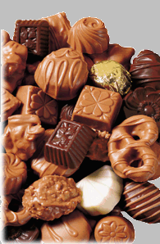
The Crime: The Great Candy Caper

Early this morning the school custodian discovered that someone had enter the school building late in the previous day by using the special code available only to the school staff. After a careful search it was revealed that the supply of candy for the School Candy Sale/Fund Raiser was missing and a note was left in its place. The note indicated that this was the act of a desperate person, obviously a candy-a-holic as it read “ Please stop me before I eat it all!”

The movements of the intruder, searching for the candy stash, were tracked through: the cafeteria kitchen area, the art room, several classrooms and storage areas. The trail ended in the “place” that the candy was stored (this location needs to remain confidential for security purposes and will be referred to as “the place”). As investigators searched “the place” looking for clues they found traces of a substance on the floor that appeared to be tracked in on the intruder’s shoes. Investigators also found a handwritten note. These items will be given to the lab teams for analysis. As a follow up, the shoes of all staff who have access to the building were scraped for evidence. Out of the entire staff, six had shoe scrapings that were suspicious and alibis that were not supported (these people could not provide a witness to support their story). These staff members were asked to hand in their favorite marker for analysis as well as an accounting of their whereabouts during the crime. Both the shoe scrapings and markers were forwarded to the crime lab.

Alibis: When questioned about their whereabouts at the time of the crime, the suspects answered as follows:

Suspect 1: I resent this accusation and in my heart know that justice will prevail. As for my whereabouts at the time of the crime, I was at home by myself watching reruns of the “Iron Chef”, my idol.

Suspect 2: Well, that is the time of day that I go out into the woods to play my bagpipes as my neighbors kept reporting me to the authorities for torturing my cat. I don’t own a cat.

Suspect 3: I didn’t want this to get out to the public but I guess it can’t be helped. I was in my basement practicing my roller blade routine for the Roller Dance competition. You see, I wanted to surprise everyone and now it’s all ruined!! I have to go lay down.

Suspect 4: Oh dear, I’m afraid my companion at that time won’t be much help in supporting my whereabouts. You see I was out walking with my best friend, Tom (he’s my pet turtle). We’ve had so many close calls with traffic that now we go to secluded spots for our walks and he tells me all about his day. You won’t want to question him, he’s very shy.

Suspect 5: I’m not talking. I want to call my lawyer.
Suspect 6: My friends all think that I’m a big social type person but actually I lead a very quiet lifestyle. At the time of the crime I was at home, sitting in the closet and doing my meditation.

Crime Lab Teams:

Each crime lab team will analyze a sample of a suspect’s “shoe scrapings” and favorite marker (chromatography analysis) to compare to the evidence found at the crime scene. (One group will analyze the evidence.) The samples will be assigned to you by your Lab Director. If there is the proper number of groups it would be best to evaluate each sample twice, as a control for data accuracy.

Procedures: Each team will be utilizing the procedures that they have studied and sharing their data with the rest of the lab teams.

Data: The data should be organized on a chart by each team and then shared by the group.

Teacher Preparation:

Powders and Crystals:
In the Science Kit you will find three containers marked A, B, and C. You will be using these for the “shoe scrapings”. (This will be presented to the students as previously obtained evidence.)

Materials:
7 plastic tumblers 6 markers
Containers A, B, C masking tape
teaspoon

1. Label 6 cups (plastic tumblers), 1 through 6 and label one “RE” for the Room Evidence.
2. Place 14 tsp. of sample A in cups 1 AND 2.
3. Place 14 tsp. of sample B in cups 3 AND 4
4. Place 14 tsp. of sample C in cups 5 AND 6.

Use the chart provided as a guide.
Cup Number, Suspect Shoe Scraping | Powder/Crystal Mix Letter | Marker Number | Suspect assigned to a specific Sample*
1 | A | 1
2 | A | 2
3 | B | 3
4 | B | 4
5 | C | 5
6 | C | 6
Room Evidence (RE) | Mix Letter: | Marker #: | Matching Suspect:

5. Powder/Crystal Mixes:
Select a sample to use as the room evidence (A,B or C) and record the letter choice in the chart as the RE Powder. Place 14 tsp of that sample in the cup labeled “RE” for testing.
6. Marker (Note):
Label each marker with a piece of tape assigning numbers 1-6. Be sure to use a marker to write the note which matches a Powder/Crystal Mix Sample (A,B or C) chosen as Room Evidence. (For example, if you chose Mix A for the RE, you’ll need to choose Marker 1 or 2 for the note)
Record the number of the RE marker in the chart.
7. The note should be written on a paper towel with a trailing line that can be cut of for an analysis. (see example). The teams will need to do chromatography analysis of the markers and the “Note”.

CHECK: THE LETTER AND MARKER OF THE “RE” SHOULD MATCH ONE OF THE SUSPECT’S EVIDENCE

Group Testing Options: This will give your class 7 samples to identify and 7 markers (6 markers and 1 note) to analyze. Scientific methodology would call for each sample to be tested and re-tested or verified.
- 14 testing groups with each sample set being assigned to two groups (tested twice).
- 7 testing groups with a final re-testing of “RE” sample and any matches.
- 7 testing groups with each group testing 2 samples/RE
- 7 testing groups with each group testing 1 sample/RE

BUILDING THE STORY
It would be great fun to get 6 or more staff members to “play along”. The students could visit the to get their alibi’s and to have them hand over a pre-arranged marker to the evidence gathering team. There could be other suspects that are eliminated due to supported alibi’s. A bulletin board could be created with the pictures of each suspect, their alibi and the results of the data analysis posted.

ENDING

Options:
- The concluding evidence could be presented to the Principal who then privately “confronts the criminal”. The principal then reports back to the class that, due to their quick work, all the candy was recovered and the individual will be in candy-o-holic rehabilitation. Congratulation on a job well done.
- The class can be recognized by the “Lab Director” as succeeding in their trial assignment and that they all have a future as Forensic Scientists.

Sample Note (to be written on paper towel with selected kit marker)

